addison moyer

**3d generalist**

addisonbmoyer@gmail.com

**801.368.0073**

To: *name* Hiring Manager

From: Addison Moyer

Date: August 2019

Re: The Position of 3d Modeler and Designer

Dear, (First Name of person) and other members of the hiring committee.

I am inquiring about the position of 3d Modeler and Designer that you have posted as available. I just want you to know that with me on your team you get:

* **More peace of mind – I am committed to the tasks you give and promise that things will get done correctly.**
* *More time to hike, ski, or travel. – I’m hassle free and complete tasks on time.*
* **A Better Bottom Line – I am committed to providing quality work and I accept feedback and constructive criticism.**
* *You’ll look even better to your supervisor – I follow instructions well as well as take creative freedoms*
* **You’ll have less stress -- I am fun to be around but I keep professional and stay on task with deadlines.**

Look at what just a few of my colleges and former supervisors have had to say about me:

*“He understands the principles of animation well, he did a really great animation for the November 2018 Eleven second club competition”*

**Fritz Dittmer –** classmate UVU

*“Now, the rest of the plan is simple. I fly to the moon... I shrink the moon... I grab the moon... I sit on the toilet... Wait, what?!*

Gru – Despicable Me

*“You couldn't hear a dump truck driving through a nitroglycerin plant.”*

Uncle Lewis – Christmas Vacation

In conclusion I know that I will be an asset to your team. Please look at my resume and portfolio to see examples of projects and things that I have created or helped create. Thank you for your consideration, and please reach out to me at **801-368-0073** or at **addisonbmoyer@gmail.com**

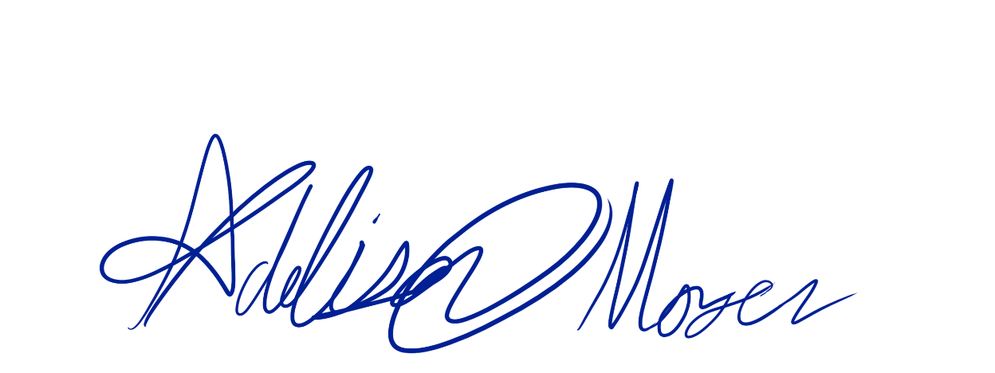

Addison Moyer

P.S. I’m actively seeking employment so I necessarily have my application out to a number of different employers, however it has long been a dream of mine to work at your company, so please call me for an interview before I have to accept employment somewhere else.